Select one question from Question 11 through Question 14, and mark 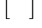 which question you have selected on your answer sheet.
If you select two or more questions, only the first selected question will be graded.

Q11. Carefully read the explanation of the following C program and then answer the sub-questions 1 through 4.

[Description of Program]
This program is a game in which the player scores points by moving the mouse pointer onto a picture of a gopher that appears on the screen and then clicking the mouse button.
(1) The screen contains a window that is divided into 16 squares in the horizontal and vertical directions. Each square consists of 24 × 24 pixels, so the window as a whole consists of 384 × 384 pixels (Fig. 1). The coordinates of each pixel are expressed as a set of horizontal and vertical coordinates, with the upper left corner of the window as the origin point (0,0).
(2) The program uses a random number to select a square and displays a picture of a gopher (Fig. 2) in that square. The picture of the gopher is displayed only while a loop is executed for a number of times declared within the program; when the loop ends, the picture of the gopher disappears simultaneously.
(3) If the player clicks within the square where the gopher is displayed, the picture of the gopher changes to the picture shown in Fig. 3, and the player is awarded a point.

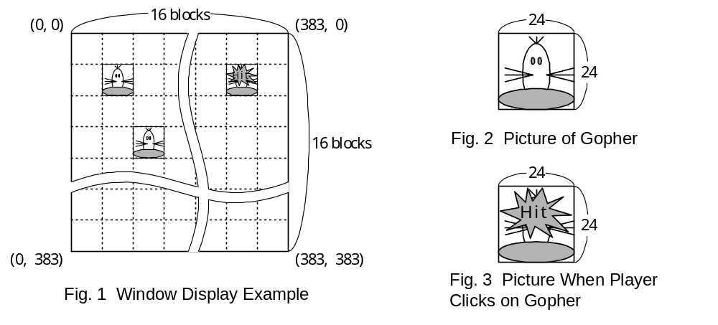

(4) The function “sense” is used to detect the mouse click and to get the coordinates where the mouse was clicked.
(5) This program uses the following three functions:
① Function: rand16
• Syntax: int rand16( void );
• Process: Generates a random integer from 0 to 15.
• Argument: None
• Return value: Integer value from 0 to 15
② Function: gopher
• Format: void gopher(char *p1, int p2, int p3);
• Function:
When argument p1 is “open”: Displays Fig. 2 in the square specified by p2 and p3.
When argument p1 is “hit”: Displays Fig. 3 in the square specified by p2 and p3.
When argument p1 is “close”: Deletes the figure in the square specified by p2 and p3.
• Arguments:
p1: Processing mode (Three modes: “open,” “hit,” and “close”).
p2: Column number of square (0 to 15).
p3: Row number of square (0 to 15).
• Return value: None
③ Function: sense
• Syntax: int sense( int *p1, int *p2 );
• Process: Detects a mouse click. When this function is first called, it returns a “0,” indicating no clicks. The next time this function is called, it detects whether there have been any mouse clicks since the last time the function was called. If it detects a click, this function returns a “1,” indicating that a click occurred, and the coordinates of the click. If it does not detect any clicks since the last time it was called, this function returns a “0,” indicating no clicks. If the mouse was clicked twice or more since the last time the function was called, the coordinates of the first click are returned.
• Arguments:
p1: Pointer to the horizontal coordinate of the pixel that was clicked.
If a mouse click is detected, the horizontal coordinate value is stored in the address pointed at by p1.
p2: Pointer to the vertical coordinate of the pixel that was clicked.
If a mouse click is detected, the vertical coordinate value is stored in the address pointed at by p2.
• Return value: Returns a “1” (ON) when a mouse click was detected, and returns a “0” when no mouse click was detected.

[Program]

(Line Number)
01 #include <stdio.h>
02 #define ON 1
03 #define OFF 0
04 #define HIT 1
05 #define CMAX 16
06 #define BLKSZ 24
07 #define MGNCNT 200
08 #define DSPCNT 250
09 #define STOP 3000

10 typedef struct { int flg; int st; } mbox;
11 int rand16(void);
12 int sense( int*, int* );
13 void gopher( char*, int, int );

14 main(void) {
15 int mflg=OFF, hitpt=0;
16 int hitck[BLKSZ][BLKSZ], gcnt, gx, gy, ix, iy;
17 mbox mg[CMAX][CMAX];

18 for ( ix=0; ix<CMAX; ix++ )
19 for ( iy=0; iy<CMAX; iy++ ) {
20 mg[ix][iy].flg = OFF;
21 mg[ix][iy].st = 0;
22 }
23 for ( ix=0; ix<BLKSZ; ix++ )
24 for ( iy=0; iy<BLKSZ; iy++ ) hitck[ix][iy] = HIT;

25 for ( gcnt=0; gcnt<STOP; gcnt++ ) {
26 if ( gcnt % MGNCNT == 0 ) {
27 ix = rand16();
28 iy = rand16();
29 if ( mg[ix][iy].flg == OFF ) {
30 mg[ix][iy].flg = ON;
31 mg[ix][iy].st = gcnt;
32 gopher( "open", ix, iy );
33 }
34 }
35 mflg = sense( &gx, &gy );
36 if ( mflg == ON ) {
37 if ( mg[gx/BLKSZ][gy/BLKSZ].flg == ON &&
38 hitck[gx%BLKSZ][gy%BLKSZ] == HIT ) {
39 hitpt += 10;
40 gopher( "hit", gx/BLKSZ, gy/BLKSZ );
41 mg[gx/BLKSZ][gy/BLKSZ].flg = OFF;
42 mg[gx/BLKSZ][gy/BLKSZ].st = 0;
43 }
44 else hitpt--;
45 }
46 for ( ix=0; ix<CMAX; ix++ ) {
47 for ( iy=0; iy<CMAX; iy++ )
48 if ( mg[ix][iy].flg == ON ) {
49 if ( (gcnt-mg[ix][iy].st)>DSPCNT ) {
50 mg[ix][iy].flg = OFF;
51 mg[ix][iy].st = 0;
52 gopher( "close", ix, iy );
53 }
54 }
55 }
56 }
57 printf( "Game Over \n your score is %d\n", hitpt );
58 }

Sub-Question 1
How many times, at a maximum, will the gopher appear before the program ends? Select your answer from the choices provided below.

Answer group:
a) 12 b) 15 c) 16 d) 20
e) 24 f) 25 g) 32

Sub-Question 2
Select TWO incorrect statements about this program from the choices provided below.

Answer group:
a) It will become easier to score points if MGNCNT in line 7 is changed to “400.”
b) It will become easier to score points if DSPCNT in line 8 is changed to “400.”
c) Changing the number of times that the gopher in Fig. 2 is displayed will change the length of time that Fig. 2 is displayed.
d) The program could end while the gopher is displayed.
e) Clicking where the gopher is not displayed affects the player’s score.

Sub-Question 3
The programmer decides to count not only the points that the player gets by clicking on the gopher, but also the number of times that the gopher gets away. Therefore, the programmer adds an int-type variable named scnt with an initial value of “0” to the declaration section, and changes printf in line 57 as follows:

printf ( "Game Over \n Your score is %d，and you let %d gophers get away \n", hitpt, scnt );

Select the correct modification that needs to be made in the function main from the choices provided below.

Answer group:
a) Add else scnt++; immediately after line 33.
b) Add else scnt++; immediately after line 34.
c) Change line 44 to else {hitpt--; scnt++;}.
d) Add else scnt++; immediately after line 45.
e) Add scnt++;immediately after line 52.

Sub-Question 4
The following #define line is added immediately after line 6, and the following “for” loop is added immediately after line 24. The result of these modifications is a change in the area in which clicks are recognized in a gopher square. From the choices provided below, select the illustration that most closely resembles the new click recognition area. The gray area represents the area in which clicks are recognized.

#define TSZ BLKSZ/3

for ( ix=0; ix<TSZ; ix++ ) {
for ( iy=0; iy<TSZ-ix; iy++ ) {
hitck[ix ][iy ] = OFF;
hitck[ix ][BLKSZ-iy-1] = OFF;
hitck[BLKSZ-ix-1][iy ] = OFF;
hitck[BLKSZ-ix-1][BLKSZ-iy-1] = OFF;
}
}

Answer group:
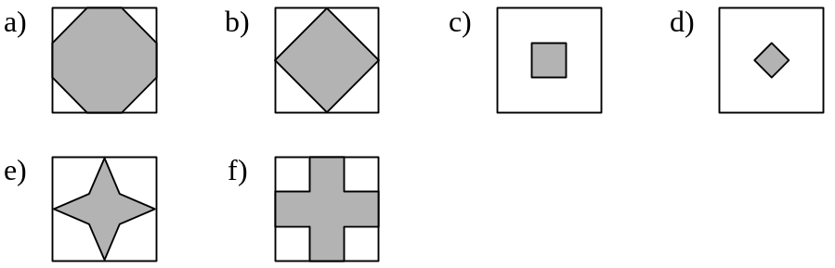
Ans: 1 – B 2 – A, C 3 - E 4 - A
Sub 1: Ta có thời gian STOP = 3000, mỗi lần khoảng thời gian MGNCNT = 200 sẽ xuất hiện một gopher. Vậy nên số Gopher tối đa có thể xuất hiện là 3000/200 = 15. Đáp án B.
Sub 2: Việc tăng thời gian khoảng cách hiển thị không làm dễ hơn vì thời gian xuất hiện của nó vẫn như cũ. Đáp án A. Thời gian hiển thị không liên quan đến số lần hiển thị. Đáp án C
Sub 3: Gopher trốn mất tương ứng với việc gọi hàm gopher(“close”, ix, iy). Đáp án E
Sub 4: Diện tích check được thu gọn, phần đó được xét như sau:
ix = 0 -> TSZ - 1 iy = 0 -> TSZ – ix - 1
Loại bỏ (ix, iy), (ix, BLKSZ – iy – 1), (BLKSZ – ix – 1, iy), (BLKSZ – ix – 1, BLKSZ – iy -1) hay nó sẽ được loại bỏ theo cả 4 góc. Ta chỉ xét góc (ix,iy) có:
ix = 0 iy = 0 ->TSZ – 1
ix = 1 iy = 0 ->TSZ – 2
...
ix = TSZ - 1 iy = 0
=> Hình loại bỏ mang hình tam giác vuông cân ở góc. Đáp án A (do TSZ = BLKSZ/3)

